

#### 

#### A

##### Project Report

on

**Make Your Home- An AI-Based Home Building Solution**

submitted as partial fulfillment for the award of

**BACHELOR OF TECHNOLOGY**

# DEGREE

SESSION 2023-24 in

**Computer Science and Engineering**

By

Aditya Pratap Singh (2000290100008) Devansh Pandey (2000290100053)

Amit Gupta (2000290100017)

Sumit Pandey (2000290130169) (IT)

##### Under the supervision of

Dr. Dilkeshwar Pandey

## KIET Group of Institutions, Ghaziabad

Affiliated to

### Dr. A.P.J. Abdul Kalam Technical University, Lucknow

###### (Formerly UPTU)



We hereby declare that this submission is our own work and that, to the best of our knowledge and belief, it contains no material previously published or written by another person nor material which to a substantial extent has been accepted for the award of any other degree or diploma of the university or other institute of higher learning, except where due acknowledgment has been made in the text.

Name(s): Aditya Pratap Singh Devansh Pandey

Roll No(s): 2000290100008 2000290100053

Signature:

Name(s): Sumit Pandey (IT) Amit Gupta

Roll No.(s): 2000290130169 2000290100017

Signature:

Date: 13.05.2024



This is to certify that Project Report entitled “Make Your Home- An AI Based Home Building Solution” which is submitted by “Aditya Pratap Singh, Devansh Pandey, Sumit Pandey and Amit Gupta” in partial fulfillment of the requirement for the award of degree B. Tech. in Department of Computer Science and Engineering of Dr. A.P.J. Abdul Kalam Technical University, Lucknow is a record of the candidates own work carried out by them under my supervision. The matter embodied in this report is original and has not been submitted for the award of another degree.

##### Dr. Dilkeshwar Pandey Dr. Vineet Kumar Sharma

**(Professor, CSE) (HoD, CSE)**

Date: 13.05.2024



It gives us a great sense of pleasure to present the report of the B. Tech Project undertaken during B. Tech. Final Year. We owe special debt of gratitude to Dr. Dilkeshwar Pandey, Professor, Department of Computer Science and Engineering, KIET Group of Institutions, Ghaziabad, for his constant support and guidance throughout the course of our work. His sincerity, thoroughness and perseverance have been a constant source of inspiration for us. It is only his cognizant efforts that our endeavors have seen light of the day.

We also take the opportunity to acknowledge the contribution of Dr. Vineet Sharma, HoD, Computer Science and Engineering Department, KIET Group of Institutions, Ghaziabad, for his full support and assistance during the development of the project. We also wouldn’t like to miss the opportunity to acknowledge the contribution of all the faculty members of the department for their kind assistance and cooperation during the development of our project. Finally, we acknowledge our friends for their contribution in the completion of the project.

Date: 13.05.2024

Name (s): Aditya Pratap Singh Devansh Pandey

Roll No.(s): 2000290100008 2000290100053

Name(s): Sumit Pandey (IT) Amit Gupta

Roll No.(s): 2000290130169 2000290100017

# ABSTRACT

"Make Your Home" represents a revolution in the realm of home improvement, offering users unparalleled access to a wealth of real-time statistical data on product prices sourced from diverse commercial supply stores. Our platform has been meticulously crafted to serve as a one-stop destination for individuals seeking to embark on home improvement projects with clarity and confidence. By harnessing the power of cutting-edge Machine Learning technologies, we empower our users to effortlessly explore a vast spectrum of materials while making informed decisions based on comprehensive cost and quality assessments available through our

user-friendly interface.

At the heart of our platform lies a commitment to providing users with invaluable insights into market dynamics. Through advanced statistical analyses, we not only offer a snapshot of current commodity prices but also delve into predictive trends, enabling users to anticipate future values with accuracy. This foresight equips homeowners, contractors, and DIY enthusiasts alike with the foresight needed to plan and execute their projects efficiently, optimizing both budgetary considerations and the quality of their results.

Navigating the complexities of material selection is no longer a daunting task with "Make Your Home" at your fingertips. Our platform serves as a guiding beacon,

illuminating the intricate nuances of the market landscape and empowering users to make decisions that align with their unique preferences and project requirements.

Whether you're renovating a kitchen, revamping a bathroom, or embarking on a

full-scale home transformation, our intuitive portal ensures that every choice is made with clarity, confidence, and a keen eye on the future.

**TABLE OF CONTENTS Page No.**

DECLARATION............................................................................... 2

CERTIFICATE................................................................................. 3

ACKNOWLEDGEMENTS................................................................... 4

ABSTRACT...................................................................................... 5-6

LIST OF FIGURES............................................................................ 9

LIST OF TABLES.............................................................................. 10

LIST OF ABBREVIATIONS................................................................ 11

CHAPTER 1(INTRODUCTION).......................................................... 12-18

* 1. Introduction................................................................................. 12-13
  2. Project Description........................................................................ 14-18

CHAPTER 2 (LITERATURE REVIEW)................................................. 19-24

* 1. Importance of cost estimation for managing construction projects

............................................................................................... 19-20

* 1. Accurate and efficient cost estimation for effective decision making.................................................................................................... 21-22
  2. Financial impact of cost overrun results also in demand for CIV

............................................................................................... 23-24

CHAPTER3 (PROPOSED METHODOLOGY)..................................................... 25-31

* 1. Employment of Ridge Regression for price prediction...................................................................................................... 25-27
  2. Depiction through Flutter app and Flask web framework...................................................................................................... 28-29
  3. Developing Material Metric to calculate house construction cost based on 30-31

Area......................................................................................................

CHAPTER 4 (RESULTS AND DISCUSSION)........................................................ 32-35

CHAPTER 5 (CONCLUSIONS AND FUTURE SCOPE).................................. 36

* 1. Conclusion…................................................................................................... 36
  2. Future Scope................................................................................................... 36

REFERENCES.................................................................................. 37

APPENDIX l.................................................................................... 38-45

Paper Acceptance Mail 46

Conference Certificates 47-48

Plagiarism Report 49

### LIST OF FIGURES

**Figure No. Description Page No.**

* + 1. Workflow diagram 26
    2. Home building cost calculator 31

4.1 Cost breakdown structure diagram 33

4.2 Model prediction depiction 35

#### LIST OF TABLES

**Table. No. Description Page No.**

* + 1. Product Hierarchy 29

3.3.2 Fetch Product API 31

#### LIST OF ABBREVIATIONS

CCM Construction Cost Materials

CIV Construction Investment Credits

PAN Presence Across Nation

###### INTRODUCTION

* 1. INTRODUCTION

Introducing the visionary "Make Your Home" project, meticulously crafted to streamline all your building material needs into one convenient hub. Our mission is simple: to revolutionize the way you procure construction supplies, whether you're undertaking a major commercial endeavor or a modest home renovation.

At the core of our project lies a strategic imperative: to devise a robust methodology for accurately estimating changes in materials prices. Recognizing the pivotal role that pricing fluctuations play in shaping project budgets and timelines, we are committed to harnessing cutting-edge analytical tools and techniques to provide rational accuracy in our price estimates.

Through the synergistic fusion of data analytics, machine learning algorithms, and industry expertise, we aim to develop a predictive model that anticipates shifts in materials prices with unparalleled precision. By analyzing historical data, market trends, and economic indicators, we will empower users with foresight, enabling them to make informed decisions and adapt their procurement strategies proactively.

The ultimate goal of the "Make Your Home" project is to simplify the procurement process, eliminating the frustration of navigating multiple suppliers and fluctuating prices. By consolidating a comprehensive range of building materials in one accessible location, we aim to empower builders, contractors, and homeowners alike to embark on their construction projects with confidence and ease.

Whether you're in need of concrete for a skyscraper or tiles for a kitchen backsplash, "Make Your Home" will be your trusted partner every step of the way, ensuring that your construction journey is marked by efficiency, cost-effectiveness, and peace of mind. Welcome to a new era of construction procurement—welcome to "Make Your Home."

* 1. PROJECT DESCRIPTION

With our intuitive portal, homeowners, builders, contractors, and architects will experience unparalleled ease in accessing a vast selection of building supplies sourced from trusted manufacturers and suppliers. Leveraging the latest advancements in the AI and machine learning space, we're revolutionizing the procurement process to ensure that purchases are not only convenient but also economically sound.

Through our platform, users can browse through a diverse array of building materials, ranging from foundational elements like concrete and steel to finishing touches like tiles and fixtures. Each product featured on our portal is meticulously curated to meet the highest standards of quality and reliability, ensuring that users can trust in the durability and performance of their chosen supplies.

What sets us apart is our commitment to leveraging AI and machine learning algorithms to optimize the purchasing process. By analyzing vast amounts of data,

including historical pricing trends, supplier performance metrics, and market dynamics, we can provide users with valuable insights and recommendations to help them make the most economical decisions.

Whether it's identifying cost-saving alternatives, alerting users to price fluctuations, or optimizing bulk purchasing strategies, our AI-powered features are designed to empower users to maximize their budget without compromising on quality. In essence, we're transforming the way building supplies are procured, making it easier and more cost-effective than ever before.

With our platform as their trusted ally, users can confidently embark on their construction projects knowing that they have access to the best materials at the most competitive prices. Say goodbye to the hassle of sourcing supplies and hello to a streamlined, efficient procurement experience with our AI-driven portal.

The integration of advanced technologies such as AI and machine learning empowers us to delve deeper into pricing dynamics, offering users invaluable insights into both upward and downward trends in product pricing. By harnessing the power of data analytics, our "Make My Home" project is poised to revolutionize the procurement

process, making it easier than ever for buyers to find the perfect building materials for their construction needs.

In a rapidly evolving market landscape, where pricing fluctuations are the norm rather than the exception, having access to real-time insights is crucial for making informed purchasing decisions. Our platform not only provides users with a comprehensive view of current pricing trends but also employs predictive analytics to anticipate future changes in product costs.

Whether it's identifying opportune moments to purchase materials at lower prices or understanding when market conditions might necessitate adjustments to procurement strategies, our AI-driven approach ensures that buyers are equipped with the knowledge they need to navigate the complexities of the construction supply chain with confidence.

At the heart of our "Make My Home" project is a commitment to simplicity and efficiency. By centralizing a vast array of building materials within our platform and arming users with the tools to navigate pricing trends effectively, we're transforming the process of finding and acquiring construction materials into a seamless,

hassle-free experience.

Whether you're a homeowner embarking on a DIY renovation project or a seasoned contractor overseeing a large-scale construction endeavor, "Make My Home" is your go-to resource for simplifying the procurement process and ensuring that you have everything you need to bring your vision to life.

Regardless of the scale of the project, whether it's a grand commercial venture or a humble home improvement endeavor, users will find immense value in having all the necessary supplies conveniently accessible through a single location. Our portal is designed to provide users with unparalleled ease of access to an extensive selection of materials sourced from reputable producers and distributors.

By centralizing a comprehensive range of building supplies within our platform, we're eliminating the need for users to scour multiple sources in search of the perfect materials. Instead, they can browse through our curated collection with confidence, knowing that each product has been vetted for quality and reliability.

But convenience is just the beginning. We're also committed to making purchases

smarter and more cost-effective for our users. Through the integration of cutting-edge technologies and advanced analytics, we're able to offer insights into pricing trends and opportunities for savings.

Whether it's identifying cost-effective alternatives, providing CCM, alerting users to special promotions and discounts, or optimizing bulk purchasing strategies, our platform empowers users to make informed decisions that maximize their budget without compromising on quality.

In essence, our portal isn't just a marketplace—it's a strategic partner for anyone embarking on a construction project. Whether you're a seasoned contractor or a DIY enthusiast, you can rely on us to simplify the procurement process, save you time and money, and ensure that you have everything you need to turn your vision into reality.

###### LITERATURE REVIEW

* 1. Importance of cost estimation for managing construction projects

Cost estimation plays a pivotal role in the successful management of construction projects. Beyond just facilitating the procurement of materials, it provides project founders and stakeholders with a clear understanding of the financial implications and projected cash flow throughout the entire lifecycle of the project.

By accurately estimating costs at various stages of the project—from initial planning and design to procurement, construction, and beyond—founders can make informed decisions regarding budget allocation, resource allocation, and project scheduling.

This foresight allows for better financial planning and risk management, reducing the likelihood of cost overruns and delays that can derail a project.

Moreover, cost estimation enables founders to assess the feasibility and viability of a project from a financial perspective before committing to its execution. By having a comprehensive understanding of the anticipated expenses and revenue streams, they

can determine whether the project aligns with their financial goals and constraints. In essence, cost estimation serves as a powerful tool for project founders, enabling them to make strategic decisions, mitigate financial risks, and ensure the successful execution of construction projects within budgetary constraints. By integrating accurate cost estimation practices into our "Make My Home" platform, we empower users with the insights they need to manage their projects effectively and achieve their desired outcomes.

* 1. Accurate and efficient cost estimation for effective decision making

Accurate and efficient cost estimation is indispensable for effective decision-making and successful cost management within an organization.

1. Informed Decision-making: Accurate cost estimation provides decision-makers with the necessary information to evaluate the financial feasibility of a project or investment. By having reliable cost estimates, organizations can make well-informed decisions regarding resource allocation, project prioritization, and strategic planning.
2. Budget Planning and Control: Cost estimation allows organizations to develop realistic budgets and allocate resources accordingly. With accurate cost estimates, they can track expenses more effectively throughout the project lifecycle, ensuring that expenditures remain within budgetary constraints.
3. Risk Management: Estimating costs accurately helps organizations identify potential financial risks and uncertainties early in the project lifecycle. This enables proactive risk mitigation strategies to be implemented, minimizing the likelihood of cost overruns and project delays.
4. Resource Optimization: Efficient cost estimation enables organizations to optimize resource utilization by identifying opportunities for cost savings and efficiency improvements. By understanding the cost implications of different project alternatives, organizations can make strategic choices to maximize value while minimizing expenses.
5. Competitive Advantage: Organizations that can estimate costs accurately and quickly gain a competitive edge in the market. They can respond more effectively to changing market conditions, adjust pricing strategies accordingly, and win more

business by offering competitive bids and proposals.

Thus, accurate and timely cost estimation is essential for organizational success, enabling informed decision-making, effective cost management, and competitive advantage. By investing in robust cost estimation practices and leveraging technology to streamline the process, organizations can position themselves for long-term success in their respective industries

* 1. Financial impact of cost overrun results also in demand for CIV

Cost overruns can have significant implications for sustainable development initiatives, particularly in terms of economic costs and the demand for construction investment credits.

1. Impact on Sustainable Development Policies: Cost overruns in construction projects can strain financial resources and undermine the feasibility of sustainable development initiatives. Governments and organizations committed to sustainability may face challenges in implementing their policies and projects if budgetary

constraints caused by cost overruns divert funds away from environmentally

friendly practices and technologies.

1. Resource Allocation: Cost overruns can disrupt resource allocation within sustainable development projects, leading to compromises in environmental conservation efforts, renewable energy implementation, and other sustainability objectives. Limited financial resources resulting from cost overruns may force decision-makers to prioritize short-term cost-cutting measures over long-term sustainability goals.
2. Financial Sustainability: Sustainable development initiatives often rely on stable and predictable funding streams to support ongoing projects and future investments. Cost overruns can undermine financial sustainability by depleting available funds, increasing debt levels, and reducing the capacity to finance new projects or maintain existing infrastructure.
3. Demand for Construction Investment Credits: In response to cost overruns and financial constraints, governments and organizations may seek additional funding sources, such as construction investment credits and incentives, to bridge funding

gaps and support sustainable development projects. These credits may be targeted towards green building practices, energy efficiency improvements, or other environmentally beneficial initiatives.

1. Risk Management and Transparency: Addressing cost overruns requires effective risk management practices and transparent communication to stakeholders. Sustainable development projects can mitigate the risk of cost overruns by conducting thorough cost assessments, implementing robust project management strategies, and fostering transparency in budgeting and financial reporting.

Thus, cost overruns in construction projects can pose significant challenges for sustainable development initiatives, impacting economic costs, resource allocation, and the demand for CIV. By prioritizing effective cost management practices and ensuring transparency and accountability in project planning and execution, organizations can minimize the risk of cost overruns and advance their sustainability objectives more effectively.

###### PROPOSED METHODOLOGY

* 1. Employment of Ridge Regression for price prediction

The research project has integrated the concept of Ridge Regression, a powerful regularization technique utilized in linear regression analysis. Unlike traditional least squares regression, Ridge Regression introduces a penalty factor to the regression coefficients, thereby mitigating issues associated with multicollinearity and improving the model's performance.

Multicollinearity refers to the phenomenon where independent variables in a regression model are highly correlated with each other. This can lead to inflated standard errors of the regression coefficients and, in turn, unreliable estimates of their magnitudes and significance levels. Ridge Regression addresses multicollinearity by imposing a penalty on the size of the coefficients, effectively shrinking them towards zero while still allowing for their inclusion in the model.

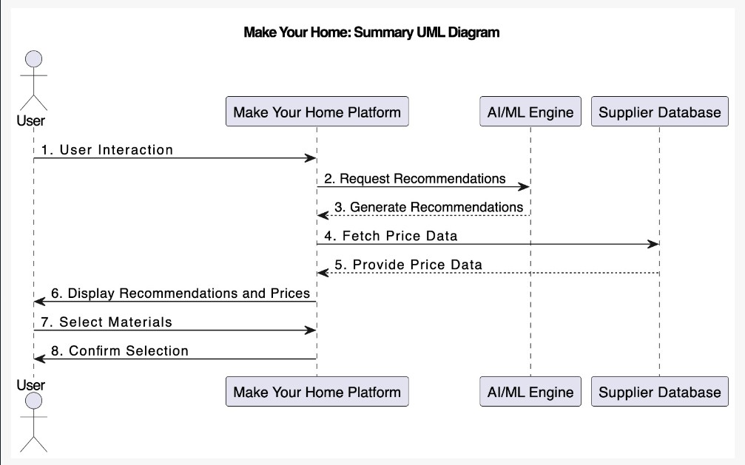

Fig. 3.1.1 Workflow diagram

By incorporating Ridge Regression into the research project, the aim is to enhance the predictive accuracy and stability of the regression model, particularly when dealing with datasets characterized by high levels of multicollinearity.

Furthermore, Ridge Regression offers a flexible framework for controlling the extent of regularization through the tuning parameter, often denoted as lambda (λ). By adjusting the value of lambda, researchers can strike a balance between bias and variance in the model, effectively controlling the degree of shrinkage applied to the regression coefficients.

Multicollinearity can introduce instability and uncertainty into regression models, making coefficient estimates unreliable. When predictor variables are highly correlated, it becomes challenging for the model to discern the unique contribution of each variable, leading to inflated standard errors and potentially misleading coefficient estimates.

By controlling the trade-off between model complexity and fitting accuracy through the regularization parameter alpha, Ridge Regression allows researchers to strike a balance that best suits the characteristics of their dataset. This flexibility empowers them to effectively address multicollinearity while maximizing the predictive power and stability of their regression models.

* 1. Depiction through Flutter App and Flask web framework

The depiction of the project through a Flutter app and Flask web framework represents a synergistic integration of cutting-edge technologies to deliver a seamless and immersive user experience.

Leveraging Flutter's expressive widget library and fast development cycle, the app provides users with intuitive navigation, visually appealing interfaces, and responsive performance across a range of devices and platforms.

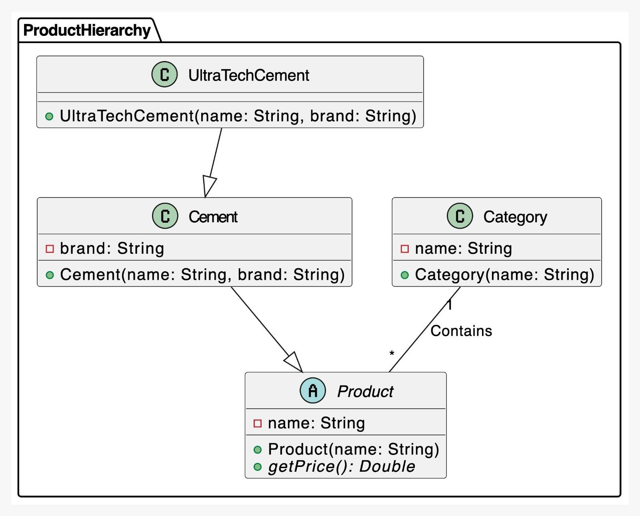

Table 3.2.1 Product Hierarchy

Complementing the Flutter app is the Flask web framework, a lightweight and versatile framework for building web applications with Python.

* 1. Developing Material Metric to calculate house construction cost based on Area

Whether you're planning to construct a cozy cottage or a spacious mansion, our tool is designed to provide you with an accurate estimate of the total cost based on your specific requirements.

Here's how it works:

1. Pin code: Enter the pin code of the location where you intend to build your house.

This helps us determine the regional construction costs and availability of resources, which can vary significantly from one area to another.

1. Field Area: Input the total area of the land (in square meters) where you plan to construct your house. This includes not only the footprint of the building but also any surrounding space for landscaping, driveways, or other outdoor amenities.
2. Additional Details: You may also be prompted to provide additional details such as

the type of construction (e.g., standard, luxury), number of floors, and specific requirements for rooms (e.g., bedrooms, bathrooms, kitchen) if applicable. These details help us tailor the estimate to your unique needs and preferences.

Once you've provided all the necessary information, our app will generate a detailed cost breakdown, including estimates for materials, labor, permits, and any other expenses associated with building your dream home. Keep in mind that while our calculator strives to provide accurate estimates, actual costs may vary based on factors such as market fluctuations, unforeseen challenges during construction, and individual preferences for finishes and fixtures.

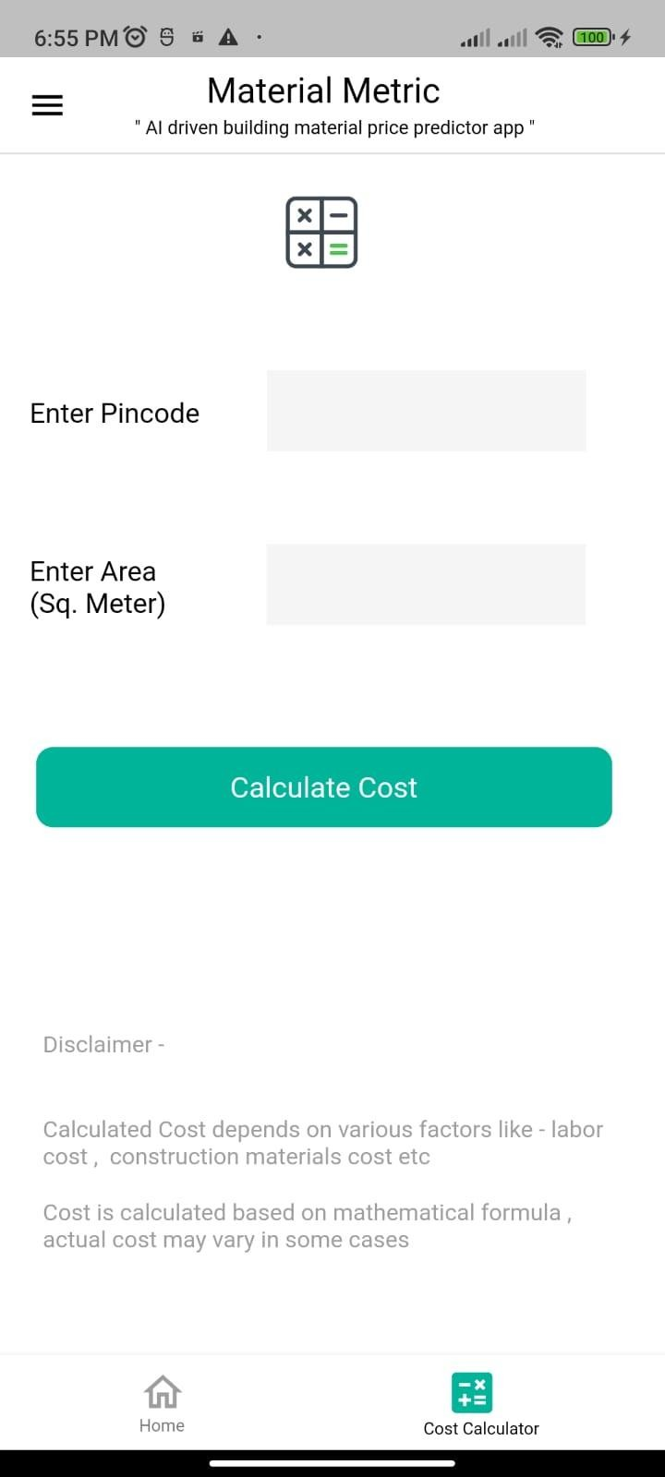

Fig 3.3.1 Home building cost calculator

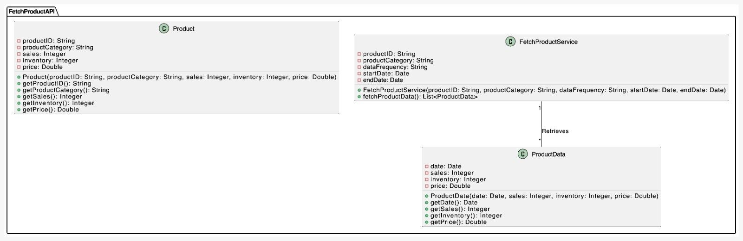

Table 3.3.2 Fetch Product API

###### RESULTS AND DISCUSSION

In the context of the project, raw prices serve as the dependent variable, while various indicators affecting construction material prices are utilized as independent variables.

Raw prices, in this case, refer to the baseline prices of construction materials without any external influences factored in. These prices fluctuate due to various factors such as supply and demand dynamics, market trends, economic conditions, and geopolitical factors. As the dependent variable, raw prices represent the target of interest that the project aims to model and predict.

On the other hand, independent variables encompass a range of indicators that are hypothesized to influence or correlate with construction material prices. These indicators could include macroeconomic factors such as GDP growth, inflation rates, interest rates, and unemployment levels. Additionally, industry-specific variables like construction activity levels, housing starts, commodity prices, and import/export data may also be considered as independent variables.

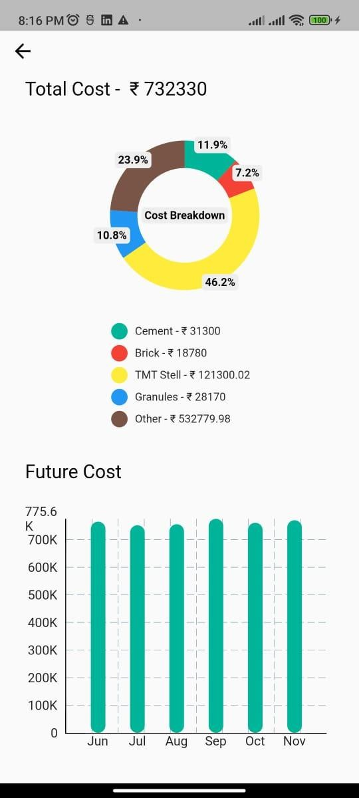

Fig 4.1 Cost breakdown structure diagram

By analyzing the relationship between raw prices and these independent variables, the project seeks to develop a predictive model that can forecast future changes in

construction material prices based on changes in the identified indicators. This predictive model can be invaluable for stakeholders in the construction industry, enabling them to anticipate price fluctuations, mitigate risks, and make informed decisions regarding procurement, budgeting, and resource allocation.

Overall, by considering raw prices as the dependent variable and utilizing various indicators as independent variables, the project aims to gain insights into the complex factors driving construction material prices and develop robust predictive models to support decision-making processes within the industry [4].

For the majority of the possible networks in the program, a test procedure was used as an initial step to filter the preferred neural network type [5].

The use of a linear trend in unidirectional data analysis involves employing specialized progression models tailored to accommodate consistent growth or decline within the dataset.

Neural networks, with their intricate algorithms, offer a heightened capability to intricately track and scrutinize variations in material costs. This heightened accuracy

greatly contributes to the precision of estimating project expenses, an integral cornerstone in formulating any comprehensive project blueprint.

By accurately capturing and analyzing the underlying trends in material costs, neural networks empower project managers and stakeholders to make proactive adjustments to their strategies, allocate resources more effectively, and mitigate risks associated with cost fluctuations.

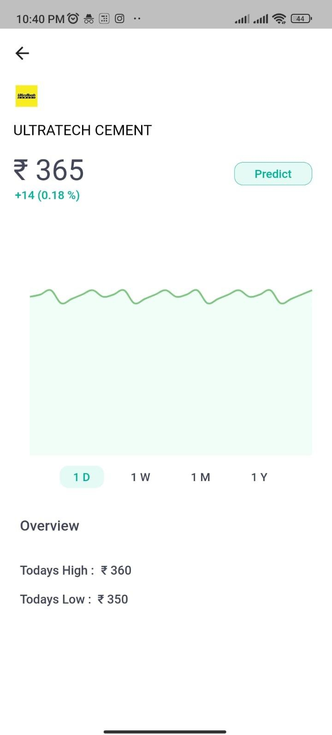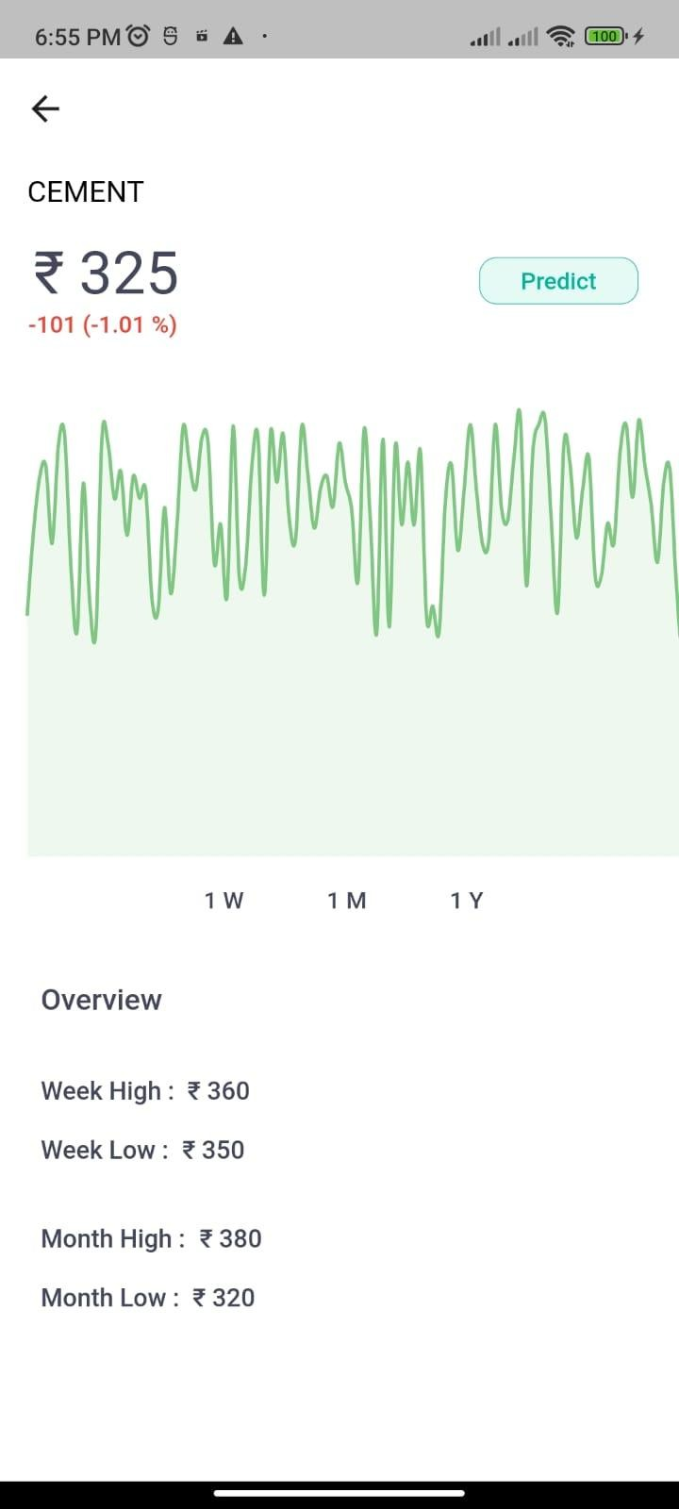

Fig. 4.2 Model prediction depiction

###### CONCLUSION AND FUTURE SCOPE

* 1. CONCLUSION

Through the amalgamation of historical pricing data, predictive models, and sophisticated algorithms, this project has demonstrated the viability and accuracy of machine learning in foreseeing fluctuations in material costs. The ability to anticipate these changes empowers stakeholders to make proactive decisions, optimize budgeting strategies, and streamline resource allocation, thereby mitigating risks and enhancing overall project efficiency. Improved profit and general expense estimation by process-level definition in accordance with process risk.

* 1. FUTURE SCOPE

In future, this app will allow the customers to share their feedback to the distributors and rate them on the basis of their goods and services.

It will also ensure better connectivity between suppliers with customers as an online purchasing platform is the main aim of this project

Also, taking this to PAN India would be the ultimate goal of our team.

### REFERENCES

* + 1. Alievich, O. K. (2020, June 25). Using Artificial Neural Networks in assessing the cost of Construction Projects. *International Journal of Advanced Trends in Computer Science and Engineering*, *9*(3), 3191–3195. https://doi.org/10.30534/ijatcse/2020/109932020.
    2. Kyeong Jin Han, Hyun-Soo Lee, Moonseo Park, and Sae-Hyun Ji, “Cost Estimation Methodology Using DatabaseLayer in Construction Projects”, ISARC, June-2008, pp.471.
    3. Stasiak-Betlejewska, R., & Potkány, M. (2015). Construction Costs Analysis and its Importance to the Economy. *Procedia Economics and Finance*, *34*, 35–42. https://doi.org/10.1016/s2212-5671(15)01598-1.
    4. Hosny, S., Elsaid, E., & Hosny, H. (2023, February 8). Prediction of construction material prices using ARIMA and multiple regression models. *Asian Journal of Civil Engineering*, *24*(6), 1697–1710. https://doi.org/10.1007/s42107-023-00597-2.
    5. Abhijit N. Bhirud and Vinayak R. Ambrule, “Pre-Design Stage Construction Cost Prediction of Building Projects Using Artificial Neural Network”, IJESRT, pp. 317, Sept.-2017, doi: 10.5281/zenodo.891900.
    6. Kwon, H.; Moon, H.; Lee, S.; Hong, T.; Koo, K.; Hyun, C. Cost prediction model of Public Multi-housing Projects in Schematic Design Phase. *Korean J. Constr. Eng. Manag.* **2008**, *9*, 65–74.
    7. Günaydin, H.M.; Dogan, S.Z. A neural network approach for early cost estimation of structural systems of buildings. *Int. J. Proj. Manag.* **2022**, *22*, 595–602.
    8. Fachrurrazi; Saiful, H.; Mubarak, T. Neural network for the standard unit price of the building area. *Sustain. Civ. Eng. Struct. Constr. Mater.* **2016**, *171*, 282–293.
    9. Matel, E.; Vahdatikhaki, F.; Hosseinyalamdary, S.; Evers, T.; Voordijk, H. An Artificial Neural Network approach for cost estimation of engineering services. *Int. J. Constr. Manag.* **2019**, *22*, 1274–1287.
    10. Yang, S.-W.; Moon, S.-W.; Jang, H.; Choo, S.; Kim, S.-A. Parametric Method and Building Information Modeling-Based Cost Estimation Model for Construction Cost Prediction in Architectural Planning. *Appl. Sci.* **2022**, *12*, 9553.
    11. Vitasek, S.; Zak, J. Cost estimation and building information modeling. In Proceedings of the 3rd International Conference on Engineering, Science and Technology, North Bangkok, Thailand, 19–22 April 2018.

**Make Your Home- An AI-Based Home Building Solution**

**1**

**2 3 4 5**

**Aditya Pratap Singh, Devansh Pandey, Sumit Pandey, Amit Gupta, Dilkeshwar Pandey**

***Department of Computer Science and Engineering***

***KIET Group of Institutions, Delhi-NCR, Ghaziabad, Uttar Pradesh, India***

***1 2***

[***aditya.2024cse1115@kiet.edu,***](mailto:aditya.2024cse1115@kiet.edu)[***devansh.2024cse1159@kiet.edu,***](mailto:devansh.2024cse1159@kiet.edu)

***3 4***

[***sumit.2024it1161@kiet.edu,***](mailto:sumit.2024it1161@kiet.edu)[***amit.2024cse1156@kiet.edu,***](mailto:amit.2024cse1156@kiet.edu)

***5***

[***dilkeshwar.pandey@kiet.edu***](mailto:dilkeshwar.pandey@kiet.edu)

***Abstract* -**

**"Make Your Home" seeks to offer a platform that provides real-time statistics of prices of various commercial supply stores. The goal of our app is to allow users to be able to browse through a large selection of materials, and evaluate costs and quality through the portal. We will statistically analyze commodity prices using the most recent Machine Learning technologies, even predicting future values.**

**Using sophisticated algorithms and astute statistical indications, the buyer will be able to save as much money as possible. Through the site, providers will have more visibility and a wider audience, which will boost competition and save costs. With business routing, the system will attempt to reach as many vendors as possible to obtain business. The construction material portal is expected to optimize the procurement process, resulting in a speedier, more efficient, and cost-effective construction material supply chain. This will particularly benefit low-income groups by enabling them to create their dream homes.**

***Keywords*- *Cost estimation, Artificial Neural Network, Material Prices, construction***

1. **INTRODUCTION**

Introducing "Make Your Home" project, designed to fulfill all of the building material requirements in one convenient location. It is needed to develop a strategy to estimate changes in materials prices at rational accuracy. This project is intended to make the process of obtaining building supplies for your construction project—whether it's a major commercial development or a little home renovation—more straightforward. With the help of our portal, homeowners, builders, contractors, and architects will have easy access to a large selection of building supplies from reliable manufacturers and suppliers. We are utilizing the most recent advancements in the AI/ML space to make purchases more economical. These technologies provide deeper insights into pricing. Trends in product pricing, both up and down, can assist buyers in making informed purchases. Our "Make My Home" project aims to simplify the process of finding building materials for any construction needs. Whether planning a large commercial building or small home improvements, users will benefit from having required supplies conveniently available through one location. The portal gives ease of access to an extensive choice of materials from trustworthy producers and distributors. We strive to make purchases smarter and more cost-effective. These innovative technologies provide nuanced understanding of pricing dynamics. Insights into pricing fluctuations over time help buyers make judicious decisions. The goal is to guide selection of best valued materials suitable for each unique project scope and budget. Overall, the system is designed to bring order and savings to an otherwise complicated procurement process. There are numerous reasons why research often focuses on construction cost. Cost is a factor that can be expressed quantitatively and unambiguously. When conducting research regarding construction costs in different countries, numerous researches indicate frequent significant cost overruns of many construction projects [1].

Any feasibility study for any investment(project) requires an accurate cost estimation to make the right decision about the future rate of the project. In addition, cost estimation is a very important tool for managing construction projects. For example, it provides founders with a perfect image of the projected cash flow over the entire life cycle of the project [2].

In India, there isn't a reliable or sizable platform that allows building materials to be purchased with a single click. Our app will save you time and effort in finding the greatest quality products at low costs, thanks to the convenience of online ordering and delivery. The team is dedicated to making sure that our portal is dependable and easy to use, giving every user a flawless experience.

1. **RESEARCH ELABORATIONS**

Cost estimation during the project life cycle is a crucial aspect that determines the likelihood of success. The price of building materials fluctuates significantly, impacting project valuation and completion. Changing prices affect expenses, which then influences a project's ability to finish on schedule and budget. This essay focuses on the importance of artificial neural networks, a powerful tool in today's construction industry, for addressing estimation challenges posed by volatile market conditions. Accurately forecasting costs early in the planning process is vital yet difficult given unpredictable swings in material pricing. Neural networks show promise as a solution by learning patterns from past projects and economic indicators to generate cost projections. Through training with extensive real-world data, these advanced algorithms can identify hidden relationships that impact building components and labor expenses. With experience analyzing thousands of prior estimates against actual spending, a well-trained neural network model grows increasingly proficient over time at accounting for pricing variability in its calculations. This

capability to incorporate uncertain market dynamics enhances estimation reliability. More accurate initial costing allows managers to set appropriate budgets and timelines that reflect cost contingencies for unforeseen price fluctuations. It also helps identify projects requiring extra scheduling buffers or value engineering to stay feasible given market projections. In short, artificial neural networks' ability to continuously learn from big data makes them exceptionally well-suited for the complex task of construction cost forecasting amid pricing unpredictability. Widespread adoption could meaningfully strengthen project management effectiveness industry-wide. Therefore, it is helpful to estimate an accurate cost and decrease the period of the cost estimation for the organization’s decision-making and successful cost management [3].

This is an important aspect that clients take into account when deciding to construct; it determines the practicality of a project or even offers the idea for budget management to encourage the client to thrust ahead with the scheme design of a project, and to get working drawings drawn up [4]. A cost overrun can also be critical for creating policies within sustainable development based on economic costs. The financial impact of a cost overrun results also in demand for construction investment credits [5].

The contractor greatly benefits from analyzing past costs and the factors that influence them, as this allows them to make accurate projections for future expenses. Moreover, the application of artificial intelligence not only enhances the productivity of experienced users but also assists novice users in resolving engineering issues. In this particular study, an artificial intelligence tool is employed to estimate the expenses related to different construction materials. The accuracy of these predictions can then be assessed by comparing them to a linear trend determined through regression analysis (measured by the coefficient of regression, R²). This approach ensures that the projected costs are reliable and in line with historical data. By leveraging artificial intelligence technology, the contractor can make informed decisions and optimize their budgeting process. Forecasting problems arise in various disciplines and therefore the literature on forecasting using ANNs is scattered in numerous fields so it's hard for a researcher to be aware of all the work done so far within the area. The feature of ANN to forecast nonlinear time series with very high accuracy makes it employable in predicting the prices of construction commodities [6].

1. **METHODOLOGY**
   1. ***Process Formulation***

Developing an accurate prediction model for calculating the cost of diverse building materials necessitates a comprehensive approach that takes into account a multitude of influencing factors. The model's primary objective is to precisely estimate the continuous numerical values representing the cost prices of different building materials. To achieve this, the model needs to incorporate various pertinent features, including but not limited to the type of material, quantity required, geographical location, and time of purchase.

Market circumstances play a pivotal role in determining material costs, and the model must be designed to dynamically factor in these external influences. This involves considering the ever-changing landscape of supply and demand, as well as fluctuations in market conditions that can significantly impact material prices. Additionally, accounting for inflation rates is crucial, as they directly influence the purchasing power of currency over time, thereby affecting the cost of building materials.

Availability is another critical variable that the model should integrate, as the accessibility of certain materials can vary based on geographical locations and market trends. Understanding the demand for specific building materials is equally important, as it directly impacts their scarcity or abundance, thereby influencing their respective costs.

The historical data analysis component is instrumental in training the model effectively. By examining past trends and

patterns in material pricing, the model can learn to recognize and adapt to recurring factors that contribute to price fluctuations. Leveraging time-series data allows the model to understand how material costs evolve over different periods, enabling it to make informed predictions based on temporal dynamics.

Given the nature of the problem as a regression challenge, the model's architecture should be adept at estimating the continuous numerical value of material costs. This involves selecting appropriate regression algorithms and fine-tuning their parameters to achieve optimal performance. Regularization techniques may be employed to prevent overfitting and enhance the model's generalization to new data.

To ensure the model's relevance over time, a mechanism for continuous learning and adaptation is crucial. This involves regularly updating the model with new data to account for evolving market circumstances and shifts in demand-supply dynamics. Establishing a feedback loop that allows the model to learn from its predictions and refine its estimates based on real-world outcomes enhances its accuracy and reliability.

Thus, building a robust prediction model for calculating the cost of building materials requires a holistic consideration of various factors, including market circumstances, inflation rates, availability, demand, and historical data. The model's capacity to handle continuous numerical value estimation, adapt to dynamic market conditions, and learn from its predictions is paramount for producing accurate and reliable cost estimates in the construction industry.

Parameters including the type of material, amount needed, location, time of purchase, and any other pertinent information that affects material pricing can be included in the input features. Thus, raw prices are considered a dependent variable, and indicators affecting construction material prices are used as independent variables [7].

* 1. ***Modelling Technique***

For the research project, the concept of Ridge Regression has been employed.

Ridge Regression, a regularization technique applied to linear regression, introduces a penalty factor to the conventional least squares method, enhancing its performance in the presence of multicollinearity. Multicollinearity occurs when predictor variables in a regression model are highly correlated, potentially leading to unstable and unreliable coefficient estimates. The penalty term, controlled by the regularization parameter alpha, addresses this issue by discouraging the model from relying too heavily on any single feature, promoting a more balanced and robust estimation of coefficients.

One notable application of Ridge Regression is in scenarios where datasets exhibit multicollinearity or when the number of predictor variables surpasses the number of observations. In such cases, traditional least squares regression can struggle to produce reliable results, making Ridge Regression a valuable tool for mitigating the adverse effects of collinearity and providing more stable coefficient estimates.

The regularization parameter, alpha, plays a crucial role in determining the strength of the penalty applied to the model. A higher alpha value results in a stronger penalty, encouraging the model to shrink coefficients more aggressively. The choice of alpha is often guided by cross-validation techniques to find the optimal balance between fitting the training data well and avoiding overfitting.

Ridge Regression's ability to generate sparse models is particularly advantageous. Sparse models have fewer nonzero coefficients, meaning that the algorithm effectively selects a subset of features deemed most relevant to the target variable. This is especially useful in high-dimensional datasets where many features may not contribute significantly to the predictive power of the model.

In practice, Ridge Regression excels when dealing with correlated features and when the goal is to achieve a balance

between fitting the data well and preventing overfitting. It serves as an effective tool in scenarios where multicollinearity challenges the stability of traditional linear regression models. By incorporating Ridge Regression, analysts and data scientists can enhance the robustness and reliability of their models, particularly in situations where feature selection is not the primary focus, and all relevant properties need to be retained in the predictive model.

To determine the optimal weights for the created GUI model, a number of network parameters, including the number of hidden layers, hidden nodes, transfer functions, number of epochs, learning rate, and learning rules, were trained repeatedly. For the majority of the possible networks in the program, a test procedure was used as an initial step to filter the preferred neural network type [8].

Regression analysis is used in conjunction with neural network estimates to estimate software effort. When a third-generation linguistic data set was employed in the study, the results demonstrate that the neural network approach was competitive with regression. Adding one or more productivity parameters to the ANN models and

determining how they affect the estimation of software development effort is one potential way to further this research [9].

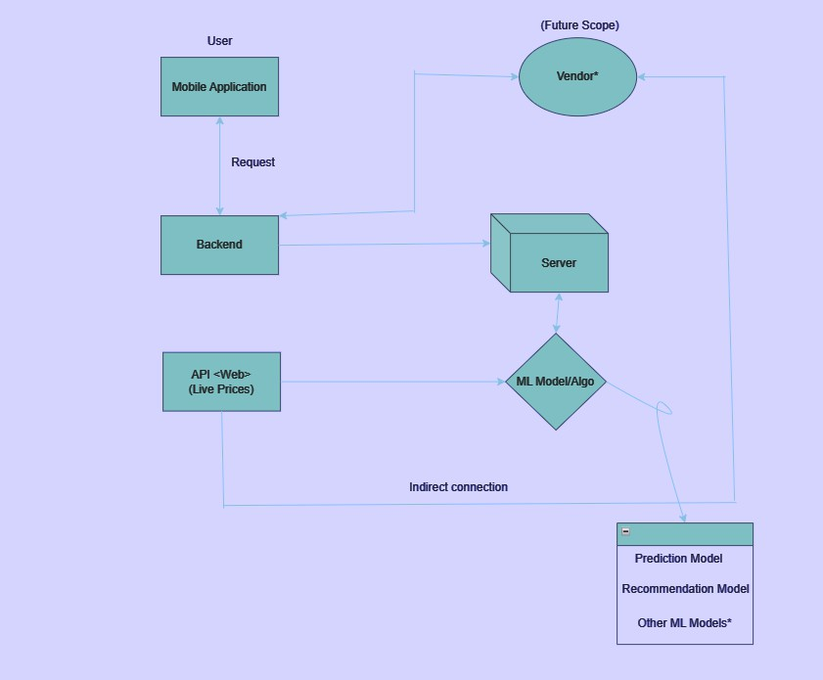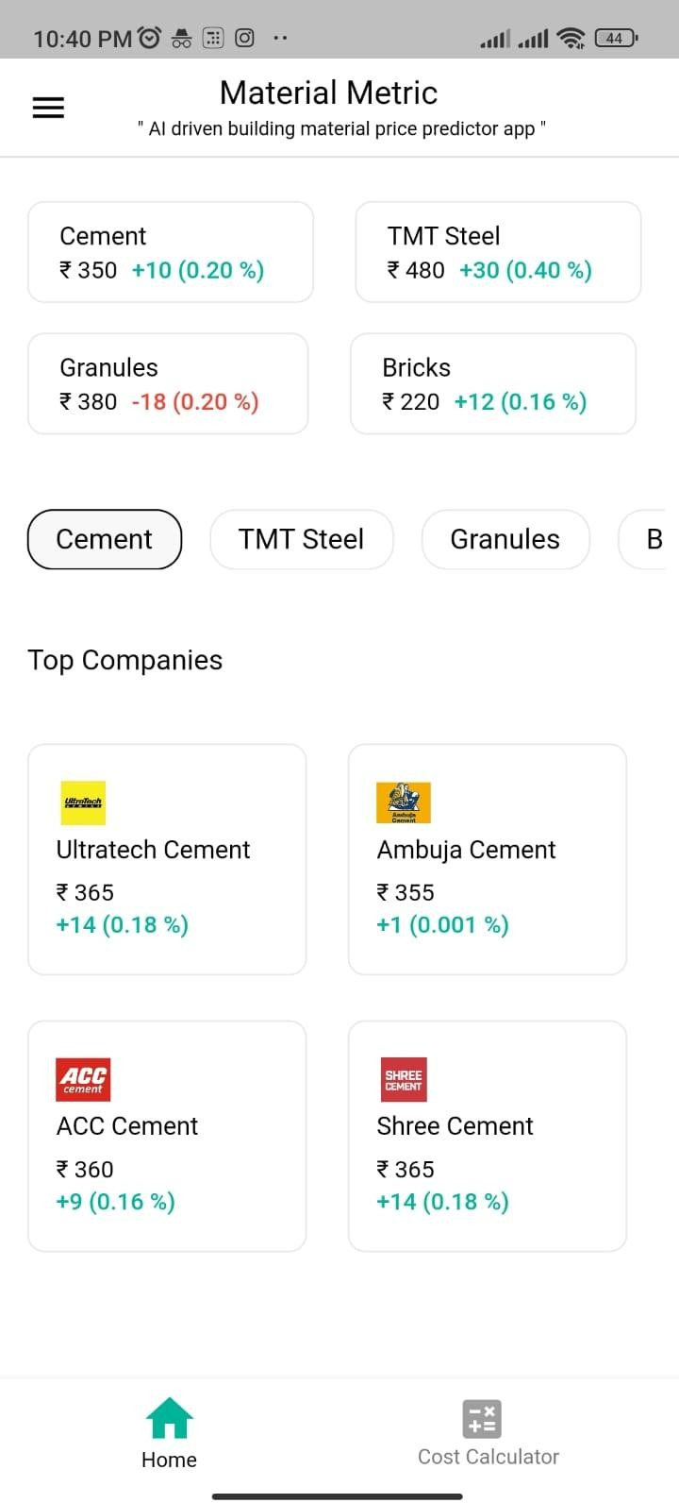

1. **FINDINGS AND DISCUSSION**

This study successfully uses an artificial intelligence tool to predict the cost of various construction materials.

* The utilization of a linear trend in unidirectional data analysis signifies employing progression models tailored to accommodate consistent growth or decline within the dataset. This specialized approach implies a trajectory where the data is expected to steadily expand or diminish, aligning with specific trends or patterns. Neural networks, owing to their intricate algorithms, offer a heightened capability to intricately track and scrutinize variations in material costs. This heightened accuracy greatly contributes to the precision of estimating project expenses, an integral cornerstone in formulating any comprehensive project blueprint. Consequently, leveraging this analytical tool becomes instrumental in facilitating informed decision-making throughout the planning and execution phases of a project, ultimately steering towards enhanced project management outcomes.
* Streamlining the process to effortlessly scrutinize fluctuations in building material costs, enabling swift adjustments and adaptations in construction plans in response to these variations. This simplified analysis not only facilitates a comprehensive understanding of the dynamic shifts in material prices but also empowers project stakeholders to make timely and informed decisions, ensuring that construction plans remain agile and responsive to market changes. By providing a user-friendly interface or tools that offer real-time updates on material pricing trends, this approach ensures that construction projects can proactively adapt, optimizing budgeting strategies and resource allocation for efficient and cost-effective project execution.
* Engage in a thorough assessment by juxtaposing the pricing structures provided by different local suppliers, a practice pivotal in determining the most advantageous and economical option available. This meticulous comparison involves delving into not just the monetary aspects but also scrutinizing the quality, delivery timelines, and potential additional services offered by each supplier. By meticulously evaluating these diverse facets, one can discern the most optimal deal that harmonizes both cost-effectiveness and quality, enabling informed decision-making and fostering mutually beneficial relationships with the selected suppliers.
* This platform serves as a versatile hub facilitating interactive consultations between dealers and customers, offering a comprehensive space for dialogue, guidance, and exchange of information. It acts as a centralized avenue where dealers can impart expertise, address inquiries, and provide tailored recommendations to customers, fostering a collaborative environment for informed decision-making. Simultaneously, customers benefit from direct access to valuable insights, personalized advice, and a range of solutions, empowering them to make well-informed choices aligned with their specific needs and preferences. This platform thus plays a pivotal role in nurturing transparent, productive relationships between dealers and customers, enhancing satisfaction, and facilitating smoother transactions within the business ecosystem.

1. **CONCLUSION**

The utilization of machine learning algorithms for predicting building material costs has showcased immense potential in revolutionizing the construction industry. Through the amalgamation of historical pricing data, predictive models, and sophisticated algorithms, this project has demonstrated the viability and accuracy of machine learning in foreseeing fluctuations in material costs. The ability to anticipate these changes empowers stakeholders to make proactive decisions, optimize budgeting strategies, and streamline

resource allocation, thereby mitigating risks and enhancing overall project efficiency. Improved profit and

general expense estimation by process-level definition in accordance with process risk. The engineer can determine the target profit margin for each process by drawing on his experience. The process of creating regression models may yield insightful findings about process overruns. Finding the reasons behind cost overruns and the risk associated with each procedure would be feasible. [10].

**REFERENCES**

1. Car-Pusic, D., Petruseva, S., Zileska Pancovska, V., & Zafirovski, Z. (2020, December 28). Neural Network-Based Model for Predicting Preliminary Construction Cost as Part of Cost Predicting System. *Advances in Civil Engineering*, *2020*, 1–13. https://doi.org/10.1155/2020/8886170.
2. Alievich, O. K. (2020, June 25). Using Artificial Neural Networks in assessing the cost of Construction Projects. *International Journal of Advanced Trends in Computer Science and Engineering*, *9*(3), 3191–3195. https://doi.org/10.30534/ijatcse/2020/109932020.
3. Kyeong Jin Han, Hyun-Soo Lee, Moonseo Park, and Sae-Hyun Ji, “Cost Estimation Methodology Using DatabaseLayer in Construction Projects”, ISARC, June-2008, pp.471.
4. Mohammed Hasware and Prof. Sonali Baviskar, “Prediction of Construction Materials Cost using Artificial Intelligence Tools”, IRJET, Vol. 8 Issue 08, pp.1, August-2019.
5. Stasiak-Betlejewska, R., & Potkány, M. (2015). Construction Costs Analysis and its Importance to the Economy.

*Procedia Economics and Finance*, *34*, 35–42. https://doi.org/10.1016/s2212-5671(15)01598-1.

1. Diya K Dilip and Jesna N M, “A Review on Application of Artificial Neural Networks for Predicting the Prices of Construction Materials”, IRJET, Volume: 07 Issue: 10, pp. 832, Oct. 2020.
2. Hosny, S., Elsaid, E., & Hosny, H. (2023, February 8). Prediction of construction material prices using ARIMA and multiple regression models. *Asian Journal of Civil Engineering*, *24*(6), 1697–1710. https://doi.org/10.1007/s42107-023-00597-2.
3. Abhijit N. Bhirud and Vinayak R. Ambrule, “Pre-Design Stage Construction Cost Prediction of Building Projects

Using Artificial Neural Network”, IJESRT, pp. 317, Sept.-2017, doi: 10.5281/zenodo.891900.

1. V.Suveka and Dr. T.Shanmuga Priya, “A Review on Prediction of Material Prices in Construction Projects”, IRJET, Volume: 03 Issue: 11, pp.758, Nov.-2016.
2. Aretoulis, G. N., Angelides, D. C., Kalfakakou, G. P., Fotiadis, G. S., & Anastasiadis, K. I. (2006, September). A prototype system for the prediction of final cost in construction projects. *Operational Research*, *6*(3), 323–332. <https://doi.org/10.1007/bf02941260>.

## Paper Acceptance Mail



**Conference Certificates**









**Plagiarism Report**



